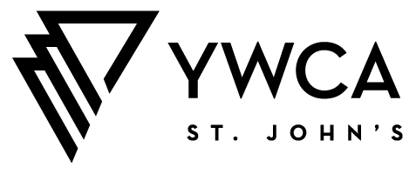
Circle of Distinction Awards 2023
- We recommend using this document to prepare your responses in advance of completing the online form, as the online form DOES NOT allow you to save responses without submitting.
- Please note that questions 4 to 8 have maximum character limits. These limits include each letter, number, and all spaces.
- All nominations must be made directly online at this link
- REMINDER: A nomination is only complete when YWCA St. John’s has received:
  - The online submission of the nomination form.
  - A letter of support from a friend, colleague, etc.; someone other than the nominator. The letter should be no longer than one full page. For the Equity at Work Award nominations only, please include two (2) two letters of support from current employees of the nominee.
  - A recent, high resolution digital photo of the nominee. In the case of a business nominee, submit a recent high resolution digital photo that reflects the nominee’s work culture and/or workforce, as well as a .jpeg or .png file of the company’s logo.
  - A completed and signed Nominee Consent Form.
Application Questions
- Nominee Information
Nominee Name:
Mailing Address:
City/Community:
Telephone Number(s):
Email Address:
Select the category for nomination:
 Trailblazer
 Social Justice and Advocacy
 Equity at Work
 Inspired Innovation
 Lifetime Achievement

The Selection Committee has the discretion to consider nominees for other categories, where appropriate, based on the scope of applications received.
Please suggest an additional nomination category for the Selection Committee to consider:
 Trailblazer
 Social Justice and Advocacy
 Equity at Work
 Inspired Innovation
 Lifetime Achievement

Some award categories have age restrictions. Please confirm the age range of the nominee:
 18 to 24
 25 to 59
 60+

- Nominator Information
Name:
Organization (if nominator is an organization):
Mailing Address:
Telephone Number(s):
Email Address:
Relationship to Nominee:
Consent of Nominator: I hereby agree to receive email correspondence from YWCA St. John’s about this nominations process and about other YWCA programs and events. I understand that I can easily unsubscribe from any mailings at any time.

- Nomination Details

Upholding the Vision, Mission, Values of YWCA St. John’s
(Value: 25 points. Character limit: 2,000.)
Outline the personal and/or professional characteristics of the nominee that make them an important player in a ‘Circle of Distinction,’ demonstrating the ways in which they are upholding the Vision, Mission and Values of YWCA St. John's. Highlight ways in which this nominee goes above and beyond the expectations of their position(s) or role(s).

Advancement of Gender-Equity
(Value: 20 points. Character limit: 2,000.)
Describe the ways in which the nominee has championed the advancement of gender equity. How have these contributions benefited or inspired others?

Nomination Category
(Value: 30 points. Character limit: 2,000.)
Describe how the Nominee meets the description of the award category for which you are nominating them. Outline major achievements, contributions, ways they have been an innovator or pioneer, and any significant projects or collaborations.

Diversity
(Value: 20 points. Character limit: 2,000.)
Describe how the nominee champions diversity through their actions and lived experiences.

Brief Summary Profile
(Value: 5 points. Character limit: 350.)
Summarize the key contributions that you feel make the Nominee a part of a ‘Circle of Distinction.’ This should be a short, concise summary of your nomination, outlining the key contributions of your nominee, which may be used in our promotional materials (consider this like a short bio of the nominee).

